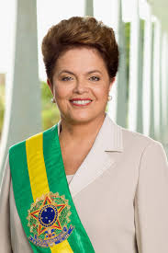  The politics of Brazil have many different branches. A federal presidential representative democratic republic, where the President is both head of state and . The political and administrative organization of Brazil comprises the federal government, the states, the federal district and the municipalities.  The federal government controls over the central government and is divided into three independent branches: executive, legislative and judicial. Executive power is exercised by the President, advised by a cabinet. Legislative powers are ruled upon the National Congress, a two-chamber legislature comprising the Federal Senate and the Chamber of Deputies. Judicial power is exercised by the judiciary, consisting of the Supreme Federal Court, the Superior Court of Justice and other Superior Courts, the National Justice Council and the Regional Federal Courts.  The states are autonomous sub-national entities with their own constitutions and governments that, together with the other federal units, form the Federative Republic of Brazil. |  | DILIMA ROUSSEFF PRESIDENT SINCE JANUARY 1, 2011  She is the first women to hold the office.  wOW  WORKERS PARTY  BACKGROUND  The first Europeans to explore Brazil was Pedro Álvares Cabral on April 22, 1500 under the sponsorship of Portugal. From the 16th to the 19th centuries, Brazil was a colony of Portugal. On September 7, 1822, the country declared its independence from Portugal and became a constitutional monarchy, the Empire of Brazil. A military coup in 1889 established a republican government. The country has seen a dictatorship (1930–1934 and 1937–1945) and a period of military rule (1964–1985).

